Business Requirements Document

**Prepared by: Zhao Fei**

Version:1.0

Month 05, 2023

Revision History

|  |  |  |  |
| --- | --- | --- | --- |
| **Version** | **Date of Revision** | **Author of Revision** | **Brief Description of Revision** |
| 1.0 | 2023.05.19 | Zhao Fei(AA/BDO1-APAC) | Creation document |
|  |  |  |  |
|  |  |  |  |
|  |  |  |  |
|  |  |  |  |
|  |  |  |  |
|  |  |  |  |
|  |  |  |  |

Reviewers

|  |  |  |
| --- | --- | --- |
| **Reviewers** | **Representing Area** | **Date of Review** |
|  | *Example: BA / Project Manager / Architect / Technical Leader* |  |
|  |  |  |
|  |  |  |
|  |  |  |
|  |  |  |
|  |  |  |
|  |  |  |
|  |  |  |

* *This table is used to track the people who review this document.*

**Table of Contents**

1 Introduction 4

1.1 Project Background 4

1.2 Project Scope 4

1.3 Definitions, Acronyms, and Abbreviations 4

2 Functional Requirements 5

2.1 Affected Functional Areas 5

2.2 Detailed Functional Requirements 5

2.2.1 Indicator List and Definition 5

2.2.2 < Requirements ID: Indicator > 6

2.2.2.1 Define < Table Name > 6

2.2.2.2 Populate < Table Name > 6

2.2.3 < Requirements ID: Indicator > 6

3 Non-functional Requirements 6

3.1 Non-functional Affected Areas 7

3.2 Performance Requirements 7

3.3 Usability Requirements 7

3.4 Security Requirements 7

3.5 Legal Requirements 8

4 Project Impact Considerations 8

4.1 Project Assumptions 8

4.2 Project Constraints 8

4.3 Project Risks 8

5 Appendix 9

# Introduction

## Project Background

* Describe current situation
  + Regional dealer send stock data via API to data platform and store as ODS data tables.
* Describe business objectives of the project
  + Consolidate dealer stock ods data and cdm data in dataplatform for dealer stock BI dashboard.

## Project Scope

* Document the scope of what this project will cover, including indicators, rules, data sources, etc.
  + Data source
    - Dealer data domain
      * Regional dealer stock
    - Product data domain
      * Global product master
      * OE cross reference
      * Alternative number
      * Dealer product number mapping
* Document the system overview and boundries.

*Example:*

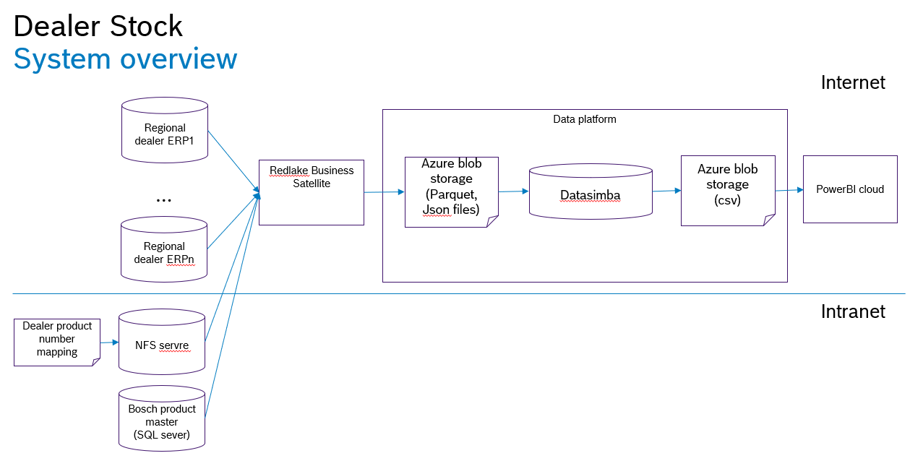

* Document functionality that is out of scope.

## Definitions, Acronyms, and Abbreviations

The first-time usage of any term, acronym, or abbreviation within this document are defined in the table below.

*Table 1. Definitions, Acronyms, and Abbreviations*

| Term | Definition |
| --- | --- |
| *Example:*  *BRD* | *Business Requirements Document. The document recording changes in work activities and work practices, usually including the introduction of new information systems and/or services, to help the organization achieve its aims and objectives.* |
|  |  |

# Functional Requirements

This section describes the detailed functional requirements.

## Affected Functional Areas

The following table is a checklist indicating areas that are or are not affected by this project. Note that “Areas” and “Considerations” are not all-inclusive, but is meant to elicit dialog between different teams and groups.

*Table 2. Affected Functional Areas*

| Areas | Considerations | Affected (Yes or No) | Manner Affected |
| --- | --- | --- | --- |
| *Financial* | *Are changes needed in Financial?*   * *Accounts Receivable?* * *Expenditures (aka Accounts Payable)?* |  |  |
| *Internet* | * *Are changes needed for the portal – public and secure?* |  |  |
|  |  |  |  |

## Detailed Functional Requirements

This section documents all detailed requirements.

### Indicator List and Definition

The following table lists all required indicators and corresponding definitions and dimensions that meet business requirements.

*Table 3. List And Definition of Indicators*

| Requirement ID | Indicator | Definition | Dimensions |
| --- | --- | --- | --- |
| *1* | *Example:*  *Sales Revenue* | *Sales revenue is the income received by the company from its sales of goods or the provision of services* | *Month, Year, Product Group, Region, Customer* |
|  |  |  |  |

### < Requirements ID: Indicator >

A new table or a changed table is required for the functional requirements < Requirements ID: Indicator >.

#### Define < Table Name >

The required table structure is as follows:

**Table name: refer to appendix1**

|  |  |  |
| --- | --- | --- |
| **Column Name** | **Column Comment** | **Data Type** |
|  |  |  |
|  |  |  |

#### Populate < Table Name >

This table will be populated with the table in the Appendix 1 - <Source to Target (Template)> .

*Table 5. Requirements ID: Indicator*

|  |  |  |  |  |  |  |
| --- | --- | --- | --- | --- | --- | --- |
| **Target Table** | | | **Source Tables** | | | |
| **Column Name** | **Description** | **Data Type** | **System** | **Table Name** | **Column Name** | **Data Type** |
| *Added Column 1* |  |  |  |  |  |  |
| *Added Column 2* |  |  |  |  |  |  |
|  |  |  |  |  |  |  |

### < Requirements ID: Indicator >

The following table describes the functional requirements <Requirements ID: Indicator>. The required table is already exists.

*Table 6. Requirements ID: Indicator*

| Requirements ID | Indicator | Requirement Description |
| --- | --- | --- |
|  |  | *Include required tables and columns, formulars, how to join tables, etc.* |
|  |  |  |

# Non-functional Requirements

This section addresses non-functional requirements not associated with specific business functions but that must be met for project success.

## Non-functional Affected Areas

The following tables delineate whether or not specific non-functional areas relating to are/are not impacted by the implementation of this project.

*Table 7. Affected Non-functional Considerations*

| Area | Description | Affected (Yes or No) | Manner Affected |
| --- | --- | --- | --- |
| *Data Retention* | *\*\* Consult with Technical Lead and/or Architect* |  |  |
| *System Logging* | *\*\* Note: To be addressed with the Architect* |  |  |
| *Disaster Recovery* | *\*\* Note: To be addressed with the Architect* |  |  |
|  |  |  |  |

## Performance Requirements

Document requirements related to the speed of response, scalability, throughput, execution time and storage capacity.

## Usability Requirements

Document requirements related to the ease of use and understandability of the system for the end-users.

## Security Requirements

This section documents requirements related to the protection of the data from unauthorized access. This includes but is not limited to the followings:

1. Authorization from the data owner is required to access data.
2. Data permission should be assigned based on user roles.
3. Provide a list of data which must be stored or displayed in an encrypted form.
4. The data should be classified, and it is mandatory to review the classification with DSP.

*Table 8. Data Classification*

|  |  |  |  |  |  |
| --- | --- | --- | --- | --- | --- |
| **Business Object** | **Data Fields** | **Personal-related Data**  **(Yes/No)** | **C-SC Security Class** | **I-SC Security**  **Class** | **A-SC**  **Security**  **Class** |
| *Example:*  *Dealer stock* | *warehouseName*  *warehouseNo*  *productName*  *productCategory*  *stockQty*  *unit*  *loadTime* | *No* | *1* | *1* | *1* |
|  |  |  |  |  |  |

## Legal Requirements

The source and use of data must comply with legal requirements. This includes but is not limited to the followings:

1. Personal Information Protection Law should be obeyed when personal information is involved.
2. Provisions on the Administration of Algorithm Recommendation of Internet Information Services must be abided by, when the requirement includes algorithm recommendation services.

# Project Impact Considerations

## Project Assumptions

The following assumptions have been made for this project:

* <Assumption 1>.
* <Assumption 2>.
* <Assumption Etc.>.

## Project Constraints

The following constraints are associated with the delivery of this project:

* <Constraint 1>.
* <Constraint 2>.
* <Constraint, etc.>.

## Project Risks

The following risks have been identified during this phase of this project:

* <Risk 1>.
* <Risk 2>.
* <Risk, etc.>.

# Appendix

The following documents provide supporting information for this project:

* Appendix 1 - <Source to Target (Template)>



* <Appendix 2> - <Name of Document 2>

<Attached Document 2>

* <Appendix, etc.> - <Name of Document, etc.>

<Attached Document, etc.>